**R Code for Examples in the book**

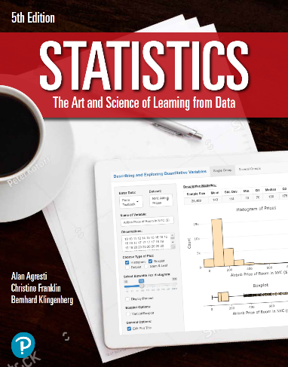

***“Statistics: The Art and Science of Learning from Data”***

**by Agresti, Franklin and Klingenberg, 5th edition**

**Chapter 3**

**Example 11: Palm Beach County – Residual**

## Reading in the data:

ballots <- read.csv(file='https://raw.githubusercontent.com/artofstat/data/master/Chapter3/buchanan_and_the_butterfly_ballot.csv')  
attach(ballots) # so we can refer to variable names

## Fitting in regression model

model <- lm(buchanan ~ perot)

## To obtain the residuals

res <- resid(model)

## Residual plot

plot(perot, res, pch = 16, col = 'darkgreen',  
 xlab = 'Perot Votes', ylab = 'Residuals',  
 main = 'Residual Plot')  
abline(0,0)

